NAME:S.ROHINI
REG.NO:192424413
DATE:19-12-2025
DAY 4
LAB EXPERIMENTS
EXP.NO-16
Scenario: You are working on a project that involves analyzing customer reviews for a product. You have a dataset containing customer reviews, and your task is to develop a Python program that calculates the frequency distribution of words in the reviews.
Question: Develop a Python program to calculate the frequency distribution of words in the customer reviews dataset?
CODE:
import pandas as pd
import re
from collections import Counter
# Load CSV file
reviews_data = pd.read_csv("customer_reviews_big.csv")
# Combine all reviews into a single string
all_reviews = " ".join(reviews_data["review_text"].astype(str))
# Convert text to lowercase
all_reviews = all_reviews.lower()
# Remove punctuation and special characters
all_reviews = re.sub(r"[^a-z\s]", "", all_reviews)
# Split text into words
words = all_reviews.split()
# Calculate word frequency distribution
word_frequency = Counter(words)
# Display most common words
print("Word Frequency Distribution (Top 20 words):\n")
for word, count in word_frequency.most_common(20):
print(word, ":", count)
OUTPUT:
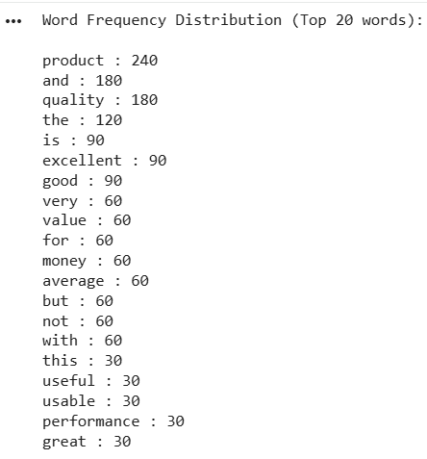
EXP.NO:17
Scenario: You are a data analyst working for a marketing research company. Your team has collected a large dataset containing customer feedback from various social media platforms. The dataset consists of thousands of text entries, and your task is to develop a Python program to analyze the frequency distribution of words in this dataset. Your program should be able to perform the following tasks:
• Load the dataset from a CSV file (data.csv) containing a single column named "feedback" with each row representing a customer comment.
• Preprocess the text data by removing punctuation, converting all text to lowercase, and eliminating any stop words (common words like "the," "and," "is," etc. that don't carry significant meaning).
• Calculate the frequency distribution of words in the preprocessed dataset.
• Display the top N most frequent words and their corresponding frequencies, where N is provided as user input.
• Plot a bar graph to visualize the top N most frequent words and their frequencies.
Question: Create a Python program that fulfills these requirements and helps your team gain insights from the customer feedback data.

CODE:
import pandas as pd
import re
from collections import Counter
import matplotlib.pyplot as plt
# Load CSV file
data = pd.read_csv("customer_feedback_big.csv")
# Combine all feedback text into one string
text = " ".join(data["feedback"].astype(str))
# Convert to lowercase
text = text.lower()
# Remove punctuation and special characters
text = re.sub(r"[^a-z\s]", "", text)
# Define stop words
stop_words = {
"the", "and", "is", "to", "of", "a", "in", "it", "for", "on",
"with", "this", "that", "was", "very", "am", "are", "but", "not"
}
# Split text into words and remove stop words
words = [word for word in text.split() if word not in stop_words]
# Calculate frequency distribution
word_freq = Counter(words)
# Take user input for Top N words
N = int(input("Enter number of top frequent words to display: "))
# Get top N words
top_words = word_freq.most_common(N)
# Print results
print("\nTop", N, "Most Frequent Words:\n")
for word, freq in top_words:
print(word, ":", freq)
# Separate words and frequencies for plotting
labels = [item[0] for item in top_words]
frequencies = [item[1] for item in top_words]
# Plot bar graph
plt.figure()
plt.bar(labels, frequencies)
plt.xlabel("Words")
plt.ylabel("Frequency")
plt.title("Top Frequent Words in Customer Feedback")
plt.xticks(rotation=45)
plt.tight_layout()
plt.show()
OUTPUT:
Enter number of top frequent words to display: 5
Top 5 Most Frequent Words:
product : 500
quality : 300
i : 300
excellent : 200
customer : 200
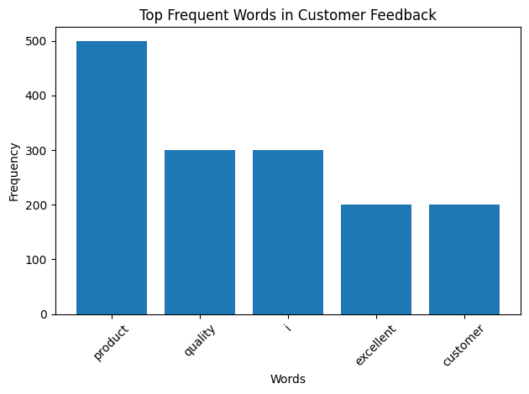

EXP.NO:18
Suppose a hospital tested the age and body fat data for 18 randomly selected adults with the following result.
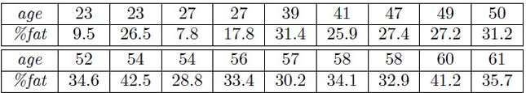
Question:
• Calculate the mean, median and standard deviation of age and %fat using Pandas.
• Draw the boxplots for age and %fat.
• Draw a scatter plot and a q-q plot based on these two variables
CODE:
import pandas as pd
import matplotlib.pyplot as plt
from scipy import stats
# Load CSV file
data = pd.read_csv("age_bodyfat_big.csv")
# 1. Mean, Median, Standard Deviation
print("STATISTICAL MEASURES\n")
print("Age:")
print("Mean:", data["age"].mean())
print("Median:", data["age"].median())
print("Standard Deviation:", data["age"].std())
print("\nBody Fat Percentage:")
print("Mean:", data["body_fat_percent"].mean())
print("Median:", data["body_fat_percent"].median())
print("Standard Deviation:", data["body_fat_percent"].std())
# 2. Boxplots for Age and %Body Fat
plt.figure()
plt.boxplot(data["age"])
plt.title("Boxplot of Age")
plt.ylabel("Age")
plt.show()
plt.figure()
plt.boxplot(data["body_fat_percent"])
plt.title("Boxplot of Body Fat Percentage")
plt.ylabel("Body Fat (%)")
plt.show()
# 3. Scatter Plot (Age vs Body Fat)
plt.figure()
plt.scatter(data["age"], data["body_fat_percent"])
plt.xlabel("Age")
plt.ylabel("Body Fat Percentage")
plt.title("Scatter Plot: Age vs Body Fat")
plt.show()

# 4. Q-Q Plots
plt.figure()
stats.probplot(data["age"], plot=plt)
plt.title("Q-Q Plot of Age")
plt.show()
plt.figure()
stats.probplot(data["body_fat_percent"], plot=plt)
plt.title("Q-Q Plot of Body Fat Percentage")
plt.show()
OUTPUT:
STATISTICAL MEASURES
Age:
Mean: 44.07
Median: 43.0
Standard Deviation: 14.44757502982505

Body Fat Percentage:
Mean: 25.912000000000003
Median: 25.15
Standard Deviation: 10.019781243201676
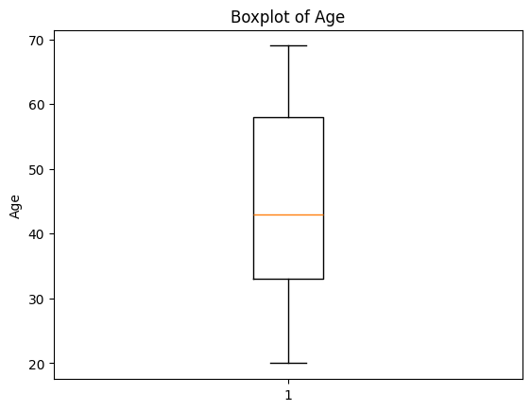
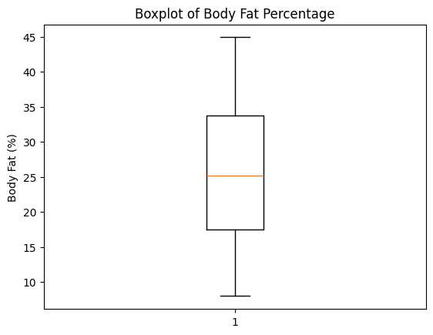
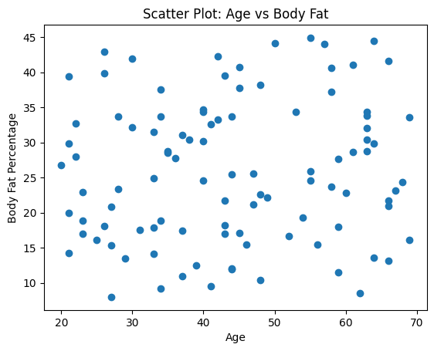
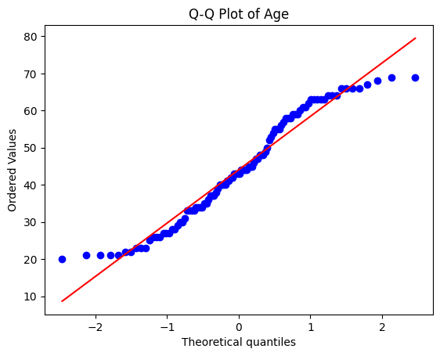
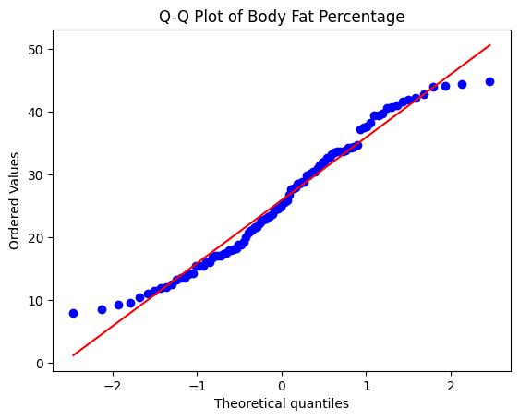
EXP.NO:19
Scenario: You are a medical researcher investigating the effectiveness of a new drug in reducing blood pressure. You conduct a clinical trial with a sample of 50 patients who were randomly assigned to receive either the new drug or a placebo. After measuring their blood pressure levels at the end of the trial, you obtain the data for both groups. Now, you want to determine the confidence intervals for the mean reduction in blood pressure for both the drug and placebo groups.
Question: "What is the 95% confidence interval for the mean reduction in blood pressure for patients who received the new drug? Also, what is the 95% confidence interval for the mean reduction in blood pressure for patients who received the placebo?
CODE:
import pandas as pd
import numpy as np
from scipy import stats
# Load CSV file
data = pd.read_csv("blood_pressure_reduction_big.csv")
# Separate the two groups
drug_group = data[data["group"] == "Drug"]["bp_reduction"]
placebo_group = data[data["group"] == "Placebo"]["bp_reduction"]
# Function to calculate 95% confidence interval
def confidence_interval(sample, confidence=0.95):
n = len(sample)
mean = np.mean(sample)
std = np.std(sample, ddof=1)
se = std / np.sqrt(n)
t_value = stats.t.ppf((1 + confidence) / 2, df=n-1)
margin_error = t_value * se
return mean - margin_error, mean + margin_error
# Calculate confidence intervals
drug_ci = confidence_interval(drug_group)
placebo_ci = confidence_interval(placebo_group)
# Print results
print("95% Confidence Interval for Drug group:", drug_ci)
print("95% Confidence Interval for Placebo group:", placebo_ci)

OUTPUT:
EXP.NO:20
Scenario: You are a data scientist working for an e-commerce company. The marketing team has conducted an A/B test to evaluate the effectiveness of two different website designs (A and B) in terms of conversion rate. They randomly divided the website visitors into two groups, with one group experiencing design A and the other experiencing design B. After a week of data collection, you now have the conversion rate data for both groups. You want to determine whether there is a statistically significant difference in the mean conversion rates between the two website designs.
Question: "Based on the data collected from the A/B test, is there a statistically significant difference in the mean conversion rates between website design A and website design B?"
CODE:
import pandas as pd
from scipy import stats
# Load CSV file
data = pd.read_csv("ab_test_conversion_big.csv")
# Separate conversion data for both designs
conversion_A = data[data["design"] == "A"]["converted"]
conversion_B = data[data["design"] == "B"]["converted"]
# Calculate mean conversion rates
mean_A = conversion_A.mean()
mean_B = conversion_B.mean()
# Perform two-sample t-test
t_stat, p_value = stats.ttest_ind(conversion_A, conversion_B)
# Print results
print("Mean conversion rate for Design A:", mean_A)
print("Mean conversion rate for Design B:", mean_B)
print("T-statistic:", t_stat)
print("P-value:", p_value)
# Decision based on p-value
alpha = 0.05
if p_value < alpha:
print("\nResult: There IS a statistically significant difference between Design A and Design B.")
else:
print("\nResult: There is NO statistically significant difference between Design A and Design B.")
OUTPUT:
